ABHINAV RANJAN

RA1911003010003

CSE A1 SECTION

SRMIST , KTR

**COMPILER DESIGN LAB**

***EXP 1 - LEXICAL ANALYZER***

**AIM :**

To write a C++ program to show the implementation of a lexical analyzer

**REQUIREMENTS :**

1. Knowledge of the working of a lexical analyzer
2. Knowledge of the concept of tokens - identifiers , operators , keywords , digits , alphanumeric , etc
3. Online compiler GDB or any compiler like Dev C++

**THEORY :**

LEXICAL ANALYSIS :

The Lexical analyzer phase is the first phase of the compilation process. It takes source code as input. It reads the source program one character at a time and converts it into meaningful lexemes. Lexical analyzer represents these lexemes in the form of tokens.

TOKENS :

Lexemes are said to be a sequence of characters (alphanumeric) in a token. There are some predefined rules for every lexeme to be identified as a valid token. These rules are defined by grammar rules, by means of a pattern. A pattern explains what can be a token, and these patterns are defined by means of regular expressions.

In programming language, keywords, constants, identifiers, strings, numbers, operators and punctuation symbols can be considered as tokens.

**ALGORITHM :**

**STEP 1 :** To take an input string and use stringstream to read the given input word by word

**STEP 2 :** The tokens are to be identified so a while loop is created in which there are conditions to identify different types of input such as keywords , operators , identifiers ,etc.

**STEP 3 :** Once the given input is scanned character by character and sorted into different categories , the output window has to display the details.

**STEP 4 :** The output console shows the details of each input character - whether they are operators or identifiers , and hence the work of the lexical analyzer is done.

**SOURCE CODE :**

#include <bits/stdc++.h>

using namespace std;

int main()

{

string s;

cout<< "Enter an input " <<endl;

getline(cin,s);

cout<<"The lexical analysis of the given input is :"<<endl;

stringstream str(s);

string ch;

while(str>>ch)

{

if(ch == "if" || ch == "else" ||

ch == "while" || ch == "do" ||

ch == "break" || ch == "continue"

|| ch == "int" || ch == "double"

|| ch == "float" || ch == "return"

|| ch == "char" || ch == "case"

|| ch == "long" || ch == "short"

|| ch == "typedef" || ch == "switch"

|| ch == "unsigned" || ch == "void"

|| ch == "static" || ch == "struct"

|| ch == "sizeof" || ch == "long"

|| ch == "volatile" || ch == "typedef"

|| ch == "enum" || ch == "const"

|| ch == "union" || ch == "extern"

|| ch == "bool")

{

cout<<ch<<" is a keyword"<<endl;

}

else if(ch[0] == ' ' || ch[0] == '+' || ch[0] == '-' || ch[0] == '*' ||

ch[0] == '/' || ch[0] == '>' || ch[0] == '<' || ch[0] == '=' || ch[0] == '(' || ch[0] == ')' ||

ch[0] == '[' || ch[0] == ']' || ch[0] == '{' || ch[0] == '}' ||

ch[0] == '&' || ch[0] == '|')

{

cout<<ch<<" is an operator"<<endl;

}

else if(ch[0] == ',' || ch[0] == ';' || ch[0] == '.')

{

cout<<ch<<" is a separator"<<endl;

}

else if(isdigit(ch[0]))

{

cout<<ch<<" is a constant"<<endl;

}

else

{

cout<<ch<<" is an identifier"<<endl;

}

}

return 0;

}

**SCREENSHOT OF OUTPUT :**

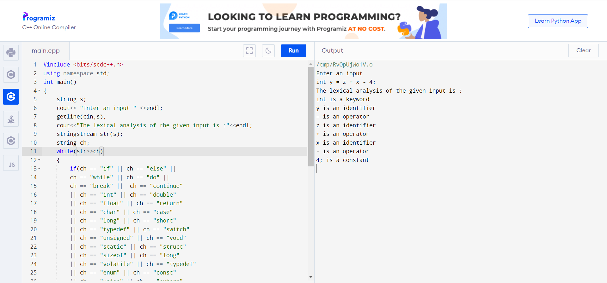

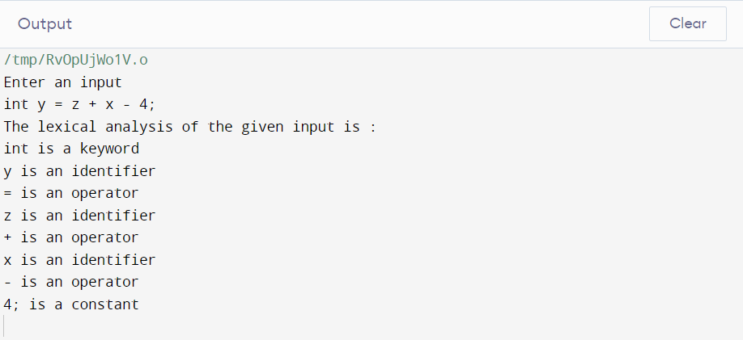

**OBSERVATION :**

Thus all the given inputs were scanned character by character and were segregated into their respective categories (like operators , identifiers , etc) which were shown in the output.

**RESULT :**

Thus we have successfully implemented a C++ program for lexical analyzer where each input character has been put in its respective category of tokens.